Major Update of Foundation Level Curriculum
iSAQB Foundation Level Working Group
(Dr. Gernot Starke, group lead)

October 16th 2026

The upcoming (April 2027) release of the Foundation Curriculum will be a major structural update and will contain many more structural changes than any previous release.

This document shall give training providers and trainers a brief overview of the schedule of these changes.

In case you are interested in structural and content-related details, please checkout our public Github repository: https://github.com/isaqb-org/curriculum-foundation

You can also follow our Kanban-board: https://github.com/orgs/isaqb-org/projects/14

The following diagram gives a brief overview, the table below explains the milestones with their respective due-dates.
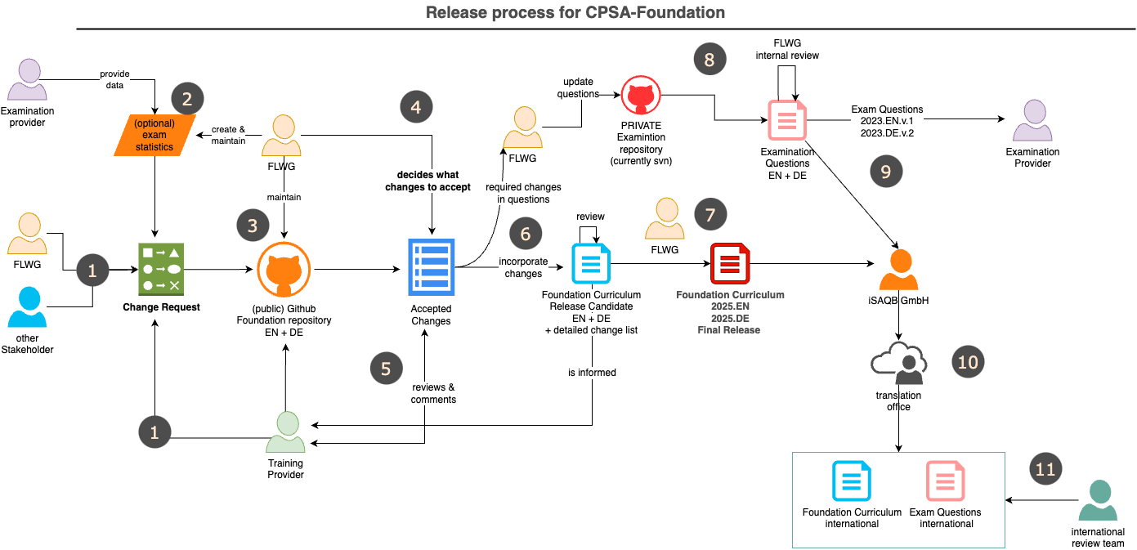
Nr | Activity | Duration | Schedule/Due-Date
1 | Initial collection of change requests.  Accepted changes are often included in main branch of repository | continuously | CRs are accepted until October 15th 2026
2 | We hope to get (anonymous) statistical evaluation of examinations and examination questions from certification providers. | continuously | none
3 | FLWG maintains the curriculum and associated information within this public Github repository
4 | FLWG decides internally, which changes to accept for the upcoming release. |  | RD - 6M, Oct 20th 2024
5 | The list of accepted changes / updated version of curriculum is given to all training providers (TP) and trainers for review and request-for-comments. From that time, TP can begin to update their training material. Several accepted changes are already included in main-branch. |  | RD - 5M, Nov 1st 2026
6 | FLWG incorporates the accepted changes in main-branch in the Github repo. Contributors from FLWG create understandable commit messages to strive for maximum transparency. All issues with "accepted" state shall be included until this date. | 8 weeks | RD - 4M, Dec 1st 2026
7 | When all changes are included and finalized, a new version of the curriculum is generated (in both EN and DE language) - but not yet made mandatory! All training providers and trainers shall be notified of this update.  This new version is published as draft on the isaqb-org.github.io website. | 4 weeks | RD - 3M, Jan 1st 2027
4, 6 & 7 | Minor corrections, hotfixes | continuously
8 | FLWG determines which exam questions are affected by the changes in curriculum and updates the exam questions accordingly. Changes to questions are reviewed internally. This will need at least three Independent reviewers | 8 weeks
9 | Finalized questions are transformed into pdf/xml and/or other formats, appropriately labelled and securely transmitted to both EP and iSAQB GmbH (to allow translation to languages other than DE and EN) EP need to incorporate this updated version into their examination process and/or toolset until the release date RD. | RD - 3M, Jan 15th 2027
10 | iSAQB GmbH contracts translation of curriculum and questions to translation office (which is under strict nondisclosure agreements) | 4 weeks
11 | For every target language there need to be an expert group who can handle review of translation | 4-6 weeks
12 | EN + DE release of curriculum and examination question: Usage of new version is mandatory in all trainings given in DE or EN.  - All training providers and trainers need to have their complete training material updated to this release  - All examination providers EP need to have completed their transition to new questions. Use of old version is NOT permitted from hereon. |  | RD, April 1st 2027
13 | International release of curriculum and examination questions. Usage of new version is mandatory in all trainings given in any language. |  | RD + max 12 weeks
- RD: Release-Date (next: April 1st 2027)
- EP: Examination Provider
- CR: Change request

